New Milton Junior School

Systematic Approach to Times Tables
A systematic approach to the teaching and learning of times tables means sequenced teaching, strong conceptual understanding, regular retrieval, explicit strategies and constant application.

1. Build on secure foundations
Before speed or recall, pupils understand what multiplication is. This prevents tables becoming ‘random’ facts without meaning.
Key ideas to secure:
- Multiplication = equal groups / repeated addition
- Arrays and grouping
- Links between multiplication and division
- Commutativity, e.g. 3 × 4 = 4 × 3
Practical strategies
- Counters, cubes, bead strings, dienes, Numicon
- Arrays – includes building and drawing own arrays
- Number lines (jumping in equal steps)
- Real-life contexts (packs, rows, teams)

2. Tables are taught in a logical sequence
A systematic order reduces cognitive load. We use the NCETM materials to sequence and teach times table strategies, using recommended models.
Progression:
- x2, x5, x10 – patterns, counting, number sense
- x3 – link to arrays and repeated addition
- x4 – double the 2s
- x8 – double the 4s
- x6 – 5s + 1 more group
- x9 – patterns, 10s minus one group
- x7 – taught using known facts from other tables
- x11 - partitioning tens and ones: 11 x 3 = 10 x 3 + 1 x 3, or 10 x add 1 more group
- x12 - partitioning: 12 x 3 = 10 x 3 + 2 x 3 (distributive law)
Each new table should explicitly link to known tables.
Year 3: Recall x2, x5, x10. Teach x3. Teach Unit: x2, x4, x8
Year 4: Recall x2, x5, x10, x3, x4, x8. Teach Unit x3, x6, x9. Teach Unit x 7. Teach x11, x12

3. Concrete → Pictorial → Abstract (CPA)
CPA is used deliberately to allow children to see the concept behind times tables and construct these themselves. This particularly supports SEND pupils and deepens understanding for all. CPA should be shown together: children manipulate concrete resources, diagrams/pictures are shown and explained, abstract fact is written in combination.
- Concrete: counters, cubes, bead strings, dienes, Numicon, shapes
- Pictorial: arrays, bar models, diagrams, number lines
- Abstract: number sentences, facts, inverses
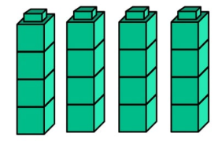

Example:
6 × 4 → 6 groups of 4 → array → 24

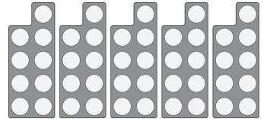
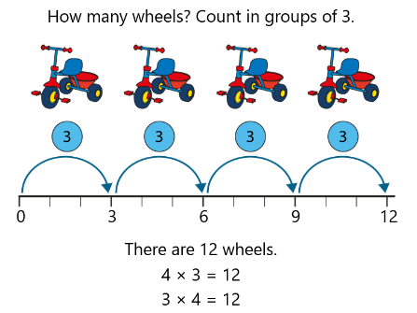
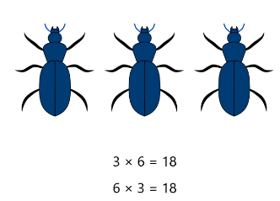

4. Daily, short, consistent practice
Frequency matters more than length.
Effective routine (5–10 minutes daily or a minimum of 3 times per week):
- Chanting with rhythm
- Call-and-response
- Flashcards (mixed, not blocked)
- Quick-fire oral questions
- Mini-whiteboard retrieval
- Times Tables Rock Stars
Use of active sessions supports learning.

5. Explicit teaching of strategies
Strategies are taught explicitly to allow children to see the connections between times tables.
Pupils are taught how to work out unknown facts using known ones: ‘What do I already know?’
- Doubling and halving
- Near facts, e.g. 6 × 7 = 6 × 5 + 6 × 2, 6 x 6 = 5 x 6 add one more group, 9 x 7 = 10 x 7 minus 1 group
- Partitioning
- Commutativity, e.g. 3 × 4 = 4 × 3
- Inverse facts (division facts alongside multiplication)
- 1, 10, 5 Derive Boards encourage understanding and application of these strategies
Key vocabulary, stem sentences and oracy techniques support understanding
Thinking aloud is modelled:
“I don’t know 7 × 8 yet, but I know 7 × 4 is 28, so I can double it.”
Stem sentences are modelled by the teacher and then used by the children.

6. Interleaving and revisiting
Systematic means constantly revisiting previously learnt times tables, not “one table at a time and forget”.
- Old and new tables are mixed when practising
- Spaced retrieval
- Regular low-stakes quizzes
- Regular practice throughout the week is timetabled in each year group
This supports long-term retention and MTC readiness.

7. Apply tables in real maths
Tables are used, not just recalled.
Tables application is embedded throughout the maths curriculum:
- Word problems
- Area and perimeter
- Scaling and measure
- Fractions (e.g. ¾ of 24), percentages and ratio
- Long multiplication and division
Children see tables as tools, not tests.

8. Intelligent assessment
Assessment guides teaching:
- Quick diagnostic checks
- Identifying patterns of errors (e.g. 6s and 8s confusion)
- Targeted interventions for specific pupils and tables
- Accuracy is encouraged over speed

9. Confidence and mindset
Fluency grows from confidence + understanding + practice.
- Times table strategies are normalised
- Effort and improvement is praised and celebrated as opposed to speed
- Games and partner work are used

