New Milton Junior School
Calculation Policy
KS2
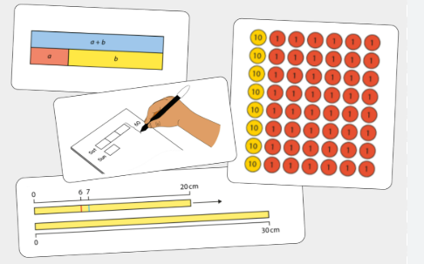

Addition Facts








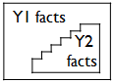

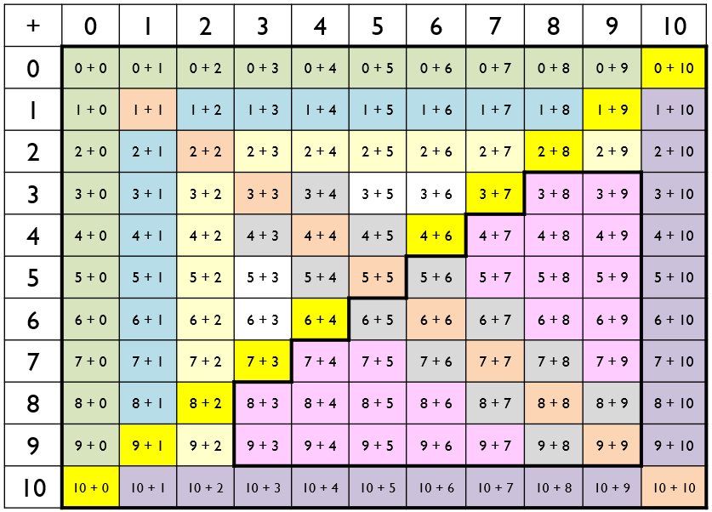
Addition
Year 3: Add numbers with up to 3-digits using formal written methods of column addition
Year 4: Add numbers with up to 4-digits using formal written methods of column addition
Years 5 and 6: Add numbers with more than 4-digits using formal written methods of column addition
Stem sentences | Concrete (Can we make it?) | Pictorial (Can we draw it?) | Abstract (Can we write the equation?)
I know that __ plus __ is equal to __. (single-digit addends)  So __ tens plus __ tens is equal to __ tens. (multiple-of-ten addends)  __ plus __ is equal to one hundred and __.  Year 3 | 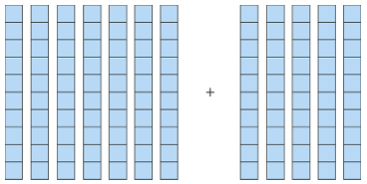  7 + 5 = 12  7 tens + 5 tens = 12 tens  70 + 50 = 120 | 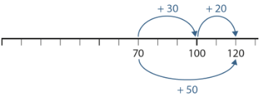  70 + 50 =  70 + 30 = 100  100 + 20 = 120 | 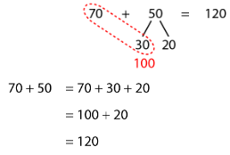
I know that __ plus __ is equal to __. (single-digit addends)  So __ tens plus __ tens is equal to __ tens. (multiple-of-ten addends)  __ plus __ is equal to one hundred and __.  Year 3 | 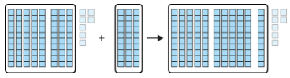  87 + 30 = 110 + 7 = 117 | 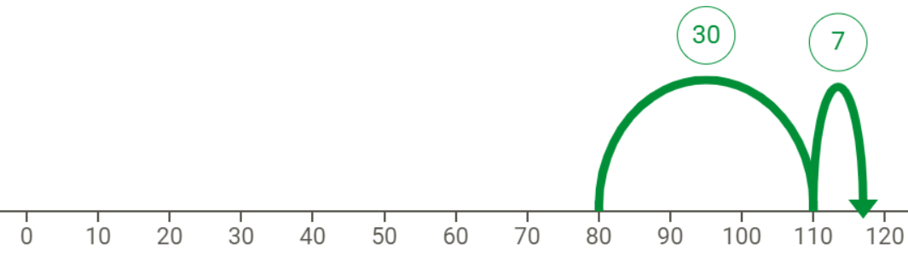  87 + 30 = 80 + 30 + 7  = 110 + 7  = 117 | 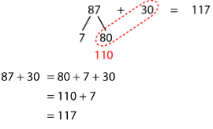
First we add: __ plus __ is equal to __ …  … then we adjust: __ minus __ is equal to __.  Year 3 | 35 + 49 = 34 + 50 = 84  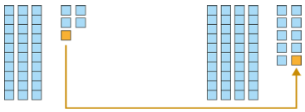 | 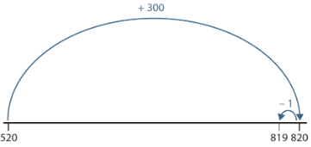  520 + 299 =  520 + 300 = 820  820 – 1 = 819 | 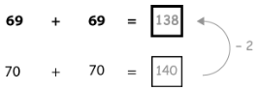

We line up the ones; __ ones plus __ ones.  We line up the tens: __ tens plus __ tens.  The __ is in the ones column – it represents __ ones. The __ is in the ones column – it represents __ ones.  __ ones plus __ ones is equal to __ ones.  The __ is in the tens column – it represents __ tens. The __ is in the tens column – it represents __ tens.  __ tens plus __ tens is equal to __ tens.  In column addition we start at the right-hand side.  Year 3 | Start with two-digit numbers to exemplify lining up the columns.  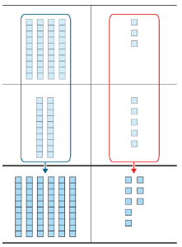 | Children draw place value counters.  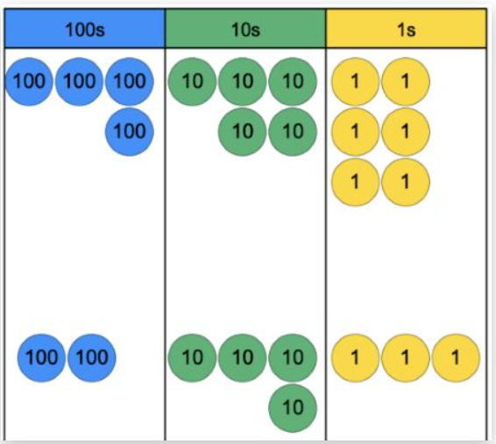 | Start with two-digit numbers to exemplify lining up the columns.  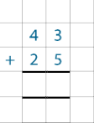  456  + 243
If the column sum is equal to ten or more, we must regroup.  Year 3 | Start with two-digit numbers to exemplify the regrouping.  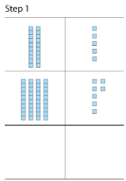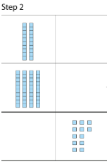  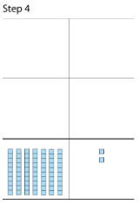  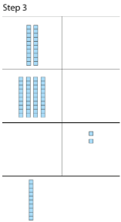 | Children draw place value counters.  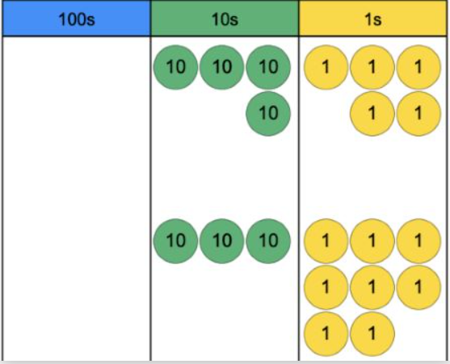 | Start with two-digit numbers to exemplify the regrouping.  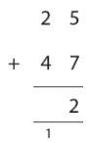  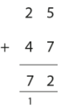  Move to 3-digit numbers  145  + 39  184  ¹
If the column sum is equal to ten or more, we must regroup.  Year 4 | See Year 3 examples | See Year 3 examples | 4-digit numbers and decimal calculation for money and measure  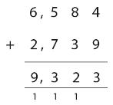  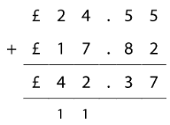
If the column sum is equal to ten or more, we must regroup.  Years 5 and 6 | See Year 3 examples | See Year 3 examples | As in Year 4 but using numbers with more than 4 digits

Addition – Key mental strategies for Key Stage 2
Strategy | Concrete (Can we make it?) | Pictorial (Can we draw it?) | Abstract (Can we write the equation?)
Bridging through a multiple of 10, 100, etc  Years 3, 4, 5 and 6 | 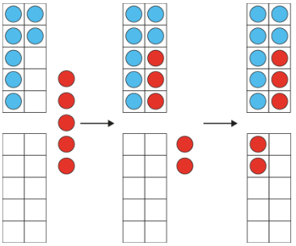  7 + 5 =  7 + 3 = 10  10 + 2 = 12 | 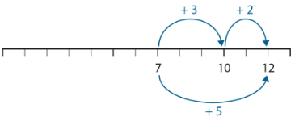  7 + 5 =  7 + 3 = 10  10 + 2 = 12 | 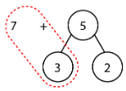  7 + 3 = 10  10 + 2 = 12
Compensating – rounding to the nearest multiple 10, 100, etc and adjusting  Years 3, 4, 5 and 6 | 35 + 49 = 34 + 50 = 84 | 520 + 299 =  520 + 300 = 820  820 – 1 = 819

Subtraction
Year 3: Subtract numbers with up to 3-digits using formal written methods of column subtraction
Year 4: Subtract numbers with up to 4-digits using formal written methods of column subtraction
Years 5 and 6: Subtract numbers with more than 4-digits using formal written methods of column subtraction
Stem sentences | Concrete (Can we make it?) | Pictorial (Can we draw it?) | Abstract (Can we write the equation?)
I know that __ minus __ is equal to __. (bridging ten)  So __ tens minus __ tens is equal to __ tens. (bridging ten tens)  One hundred and __ minus __ is equal to __.  Year 3 | 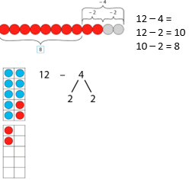  e.g. | 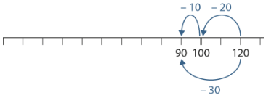  120 – 30 =  120 – 20 = 100  100 – 10 = 90 | 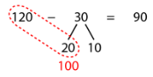  120 – 30 =  120 – 20 = 100  100 – 10 = 90
I know that __ minus __ is equal to __. (bridging ten)  So __ tens minus __ tens is equal to __ tens. (bridging ten tens)  One hundred and __ minus __ is equal to __.  Year 3 | 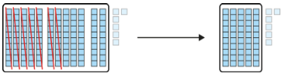  126 – 70 = 56 | 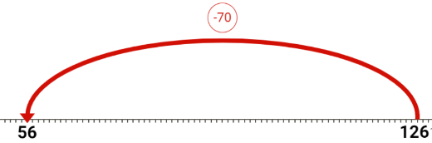 | 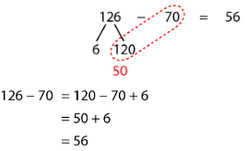
We partition the __ into __ and __.  First we subtract the __ from __ to get to a multiple of 10. Then we subtract the remaining __ from the multiple of 10. We know 10 minus __ is equal to __ so __ minus __ is equal to __.  Year 3 | 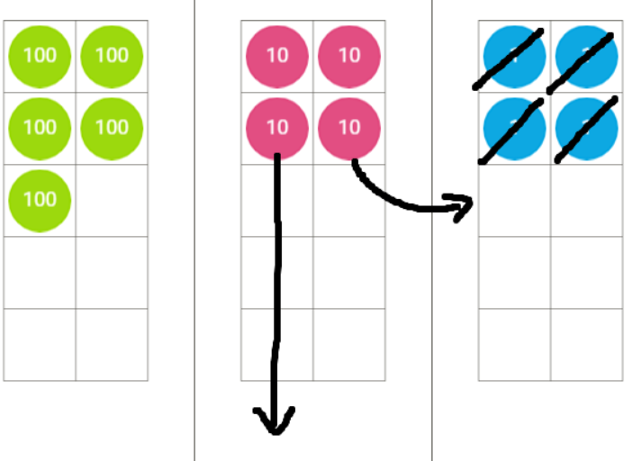 | 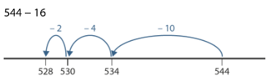 | Count back to multiples of 10/100
We partition the __ into __ and __.  First we add the __ to __ to get to 100. Then we add the remaining __ to 100. We know 100 plus __ is equal to __.  Year 3 | 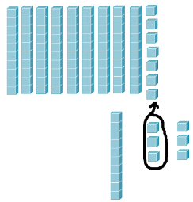 | 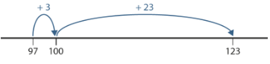123 – 97 = 26 | Count on to multiples of 10/100
We line up the ones; __ ones plus __ ones.  We line up the tens: __ tens plus __ tens.  The __ is in the ones column – it represents __ ones.  __ ones minus __ ones is equal to __ ones.  The __ is in the tens column – it represents __ tens.  __ tens minus __ tens is equal to __ tens.  In column subtraction we start at the right-hand side.  Year 3 | 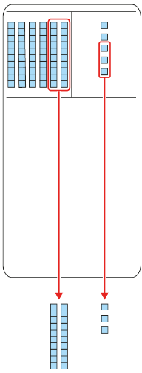 | Children draw place value counters.  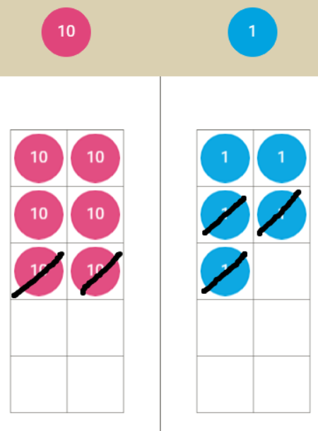 | 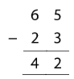  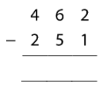
If there is an insufficient number to subtract from in a given column, we must exchange from the column to the left.  Year 3 | 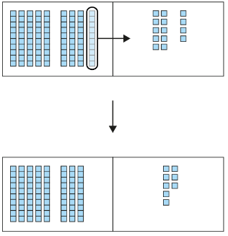  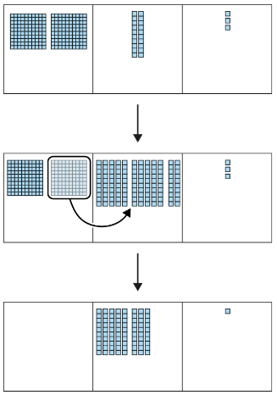 | Children draw place value counters.  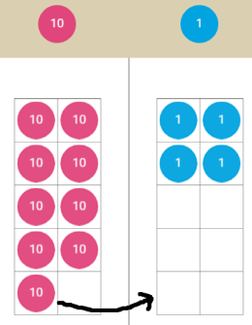  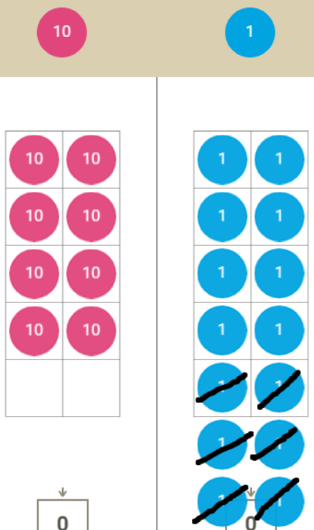 | 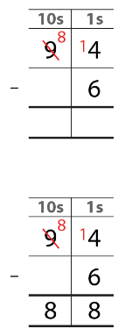  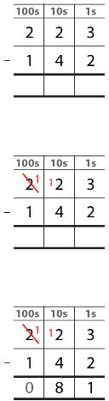
If there is an insufficient number to subtract from in a given column, we must exchange from the column to the left.  Year 4 | See Year 3 examples | See Year 3 examples | 4-digit numbers and decimal calculation for money and measure  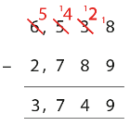  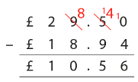
If there is an insufficient number to subtract from in a given column, we must exchange from the column to the left.  Years 5 and 6 | See Year 3 examples | See Year 3 examples | As in Year 4 but using numbers with more than 4 digits
Subtraction – Key mental strategies for Key Stage 2
Strategy | Concrete (Can we make it?) | Pictorial (Can we draw it?) | Abstract (Can we write the equation?)
Bridging through a multiple of 10, 100, etc  Years 3, 4, 5 and 6 | 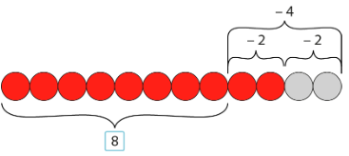  12 – 4 =  12 – 2 = 10  10 – 2 = 8  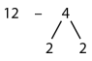 | 120 – 30 =  120 – 20 = 100  100 – 10 = 90 | 120 – 30 =  120 – 20 = 100  100 – 10 = 90
Compensating – rounding to the nearest multiple 10, 100, etc and adjusting  Years 3, 4, 5 and 6 | 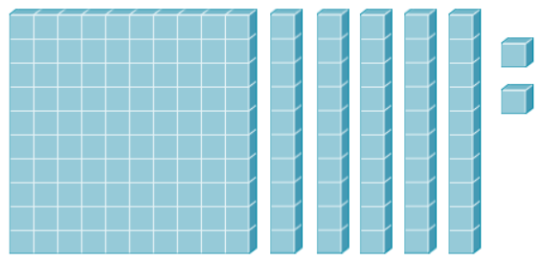  152 – 29  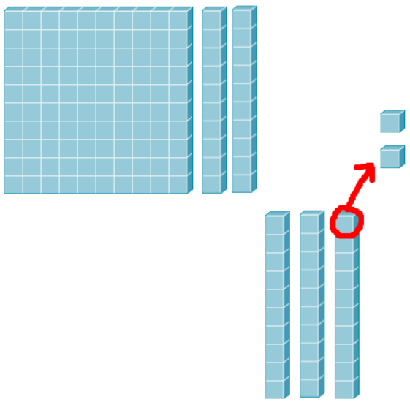 | 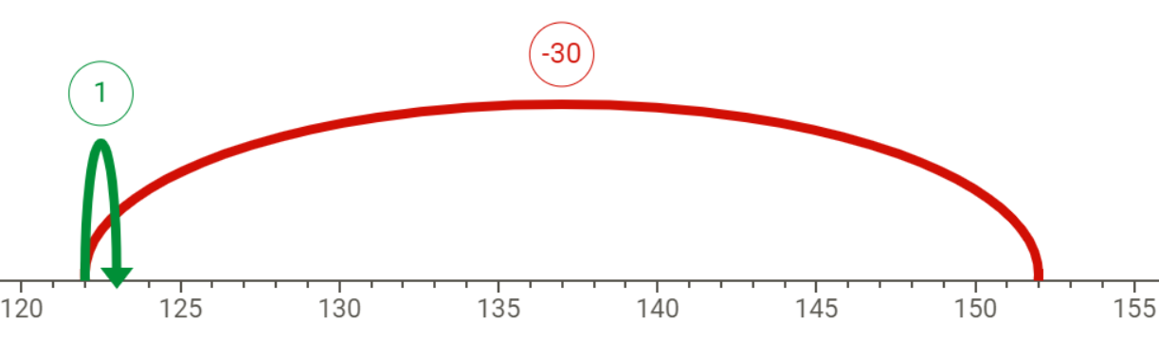 | 152 – 30 = 122  122 + 1 = 123
Multiplication
Year 3: Write and calculate mathematical statements for multiplication using the multiplication tables including for 2-digit numbers x 1-digit numbers, using mental methods and progressing to formal written methods
Year 4: Multiply two and three-digit numbers by a 1-digit number using a formal written layout
Years 5: Multiply numbers up to 4-digits by a 1 or 2-digit number using a formal written method, including long multiplication for two-digit numbers
Year 5: Multiply whole numbers including those involving decimals by 10, 100 and 1000
Year 6: Multiply multi-digit numbers up to 4-digits by a 2-digit number using the formal written method of long multiplication
Stem sentences | Concrete (Can we make it?) | Pictorial (Can we draw it?) | Abstract (Can we write the equation?)
__ is equal to __ plus __, so __ times __ is equal to __ times __ plus __ times __.  __ is equal to __ minus __, so __ times __ is equal to __ times __ minus __ times __.  Multiplication is distributive.  (NCETM Year 4 unit 2.10)  Year 3 | 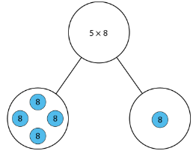 | 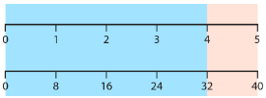 | 5 = 4 + 1  5 x 8 = 4 x 8 + 1 x 8  = 32 + 8  = 40  4 = 5 – 1  4 x 8 = 5 x 8 – 1 x 8  = 40 – 8  = 32
__ is equal to __ plus __, so __ times __ is equal to __ times __ plus __ times __.  __ is equal to __ minus __, so __ times __ is equal to __ times __ minus __ times __.  Multiplication is distributive.  (NCETM Year 4 unit 2.10)  Year 3 | 13  10 3    3 | 13  10 3  3 | 3 x 13 = 3 x 10 + 3 x 3  = 30 + 9  = 39
  30 | 9
To multiply a whole number by 10, move each digit once to the left in place value columns and place a zero after the final digit of that number.  Year 4 | 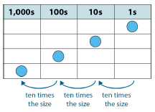  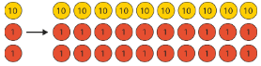 | 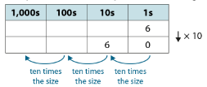  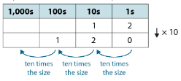 | 6 x 10 = 60  12 x 10 = 120
All multiples of 100 have both a tens and ones digit of 0.  When a number is multiplied by 100, the product is a multiple of 100.  Year 4 | 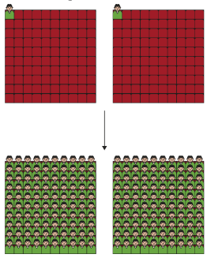  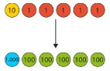 | 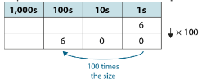  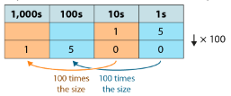 | 2 x 100 = 200  There are 100 times as many people as before.  15 x 100 = 1500
If one factor is made ten times the size, the product will be ten times the size.  Year 4 | 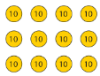  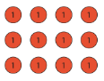 | 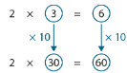 | 4 x 3 = 12 so 4 x 30 = 120
If there are ten or more ones, we must regroup the ones into tens and ones.  If there are ten or more tens, we must regroup the tens into hundreds and tens.  Multiplication is distributive.  Year 4 | 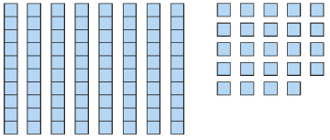  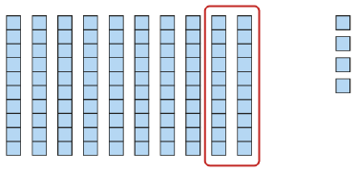  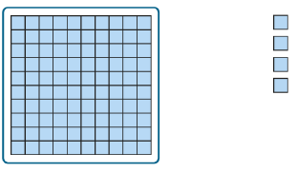  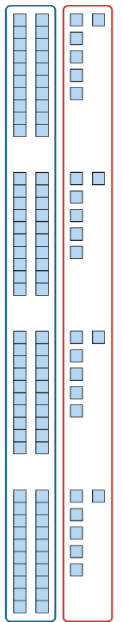 | 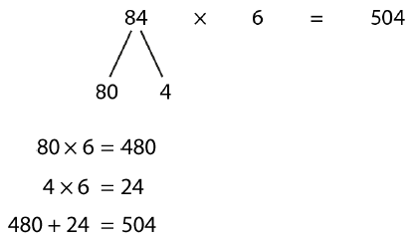 | 84 x 6 = 80 x 6 + 4 x 6  = 480 + 24  = 504
We work from the least significant digit, on the right, to the most significant digit, on the left.  Multiplication is distributive.  Year 4 | 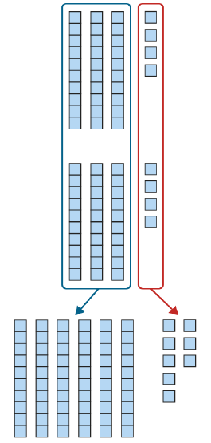 | 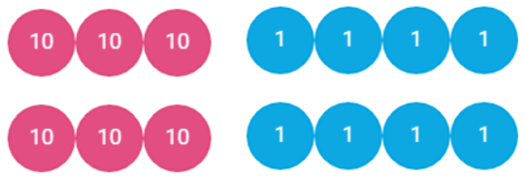  34 x 2 = 60 + 8 = 68 | 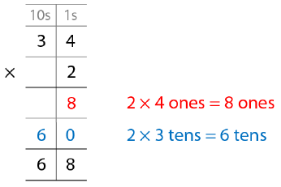  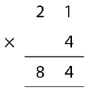
If there are ten or more ones, we must regroup the ones into tens and ones.  If there are ten or more tens, we must regroup the tens into hundreds and tens.  Multiplication is distributive.  Year 4 | 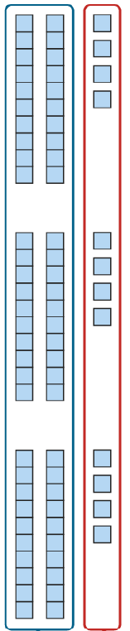  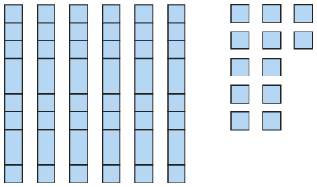  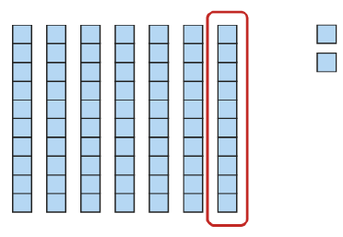 | 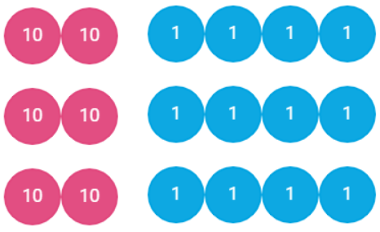  24 x 3 = 60 + 12 = 72 | 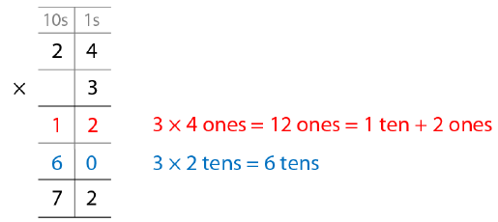  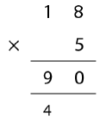  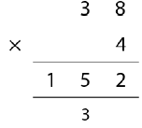
If there are ten or more ones, we must regroup the ones into tens and ones.  If there are ten or more tens, we must regroup the tens into hundreds and tens.  If there are ten or more hundreds, we must regroup the hundreds into thousands and hundred.  Multiplication is distributive.  Year 4 | 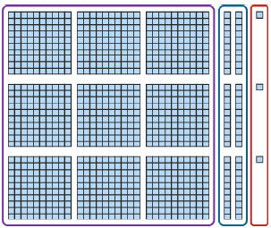  321 x 3 = 963 | 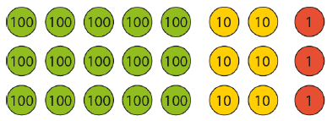  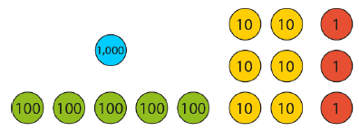  521 x 3 = 1000 + 500 + 60 + 3 = 1563 | 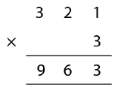  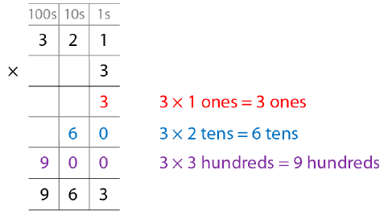  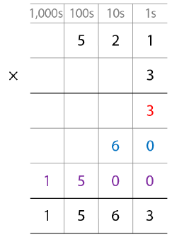  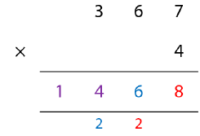
If there is a multiplicative increase in one factor and a multiplicative decrease in the other, the product remains the same.  If I multiply one factor by __, I must divide the other factor by __ for the product to remain the same.  Year 5 and 6 | 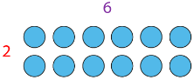  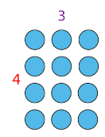  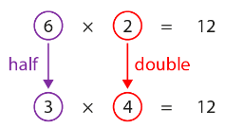 | 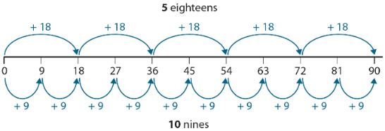 | 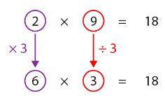
If one factor is made one tenth of the size, the product will be one tenth of the size.  If one factor is made one hundredth of the size, the product will be one hundredth of the size.  I move the digits of the number I am multiplying __ places to the left until I get a whole number; then I multiply; then I move the digits of the product __ places to the right.  Year 5 | 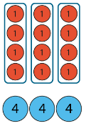  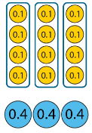  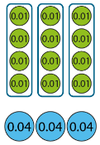  4 x 3 = 12  0.4 x 3 = 1.2  0.04 x 3 = 0.12 | 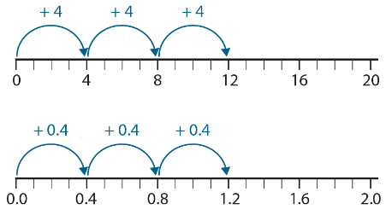 | 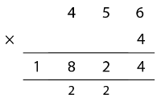  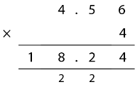
Numbers that have more than two factors are composite numbers.  Year 5 | 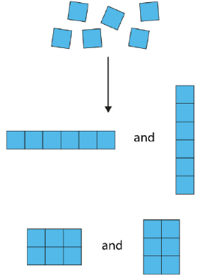  Factors of 6 are  1, 2, 3 and 6. | 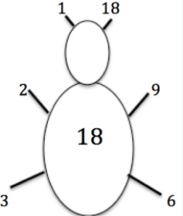  Factor bugs | Factors of 6 are 1, 2, 3 and 6.
Numbers that have only two factors are prime numbers.  Year 5 | 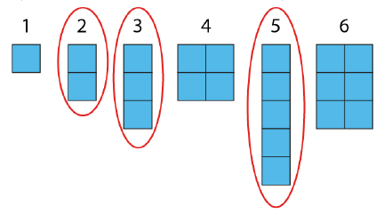 |  | 17 is a prime number because its only factors are 1 and 17.
To multiply a two-digit number by a two-digit, first multiply by the ones, then multiply by the tens, then add them together.  To multiply a three-digit number by a two-digit number, first multiply by the ones, then multiply by the tens, then add them together. Follow process for 4-digits.  Year 5 and 6 | 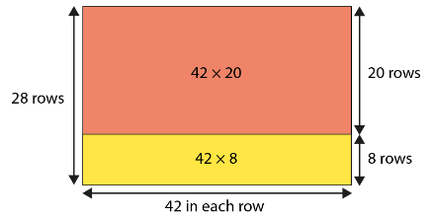 | 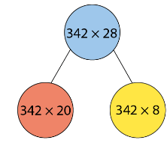 | 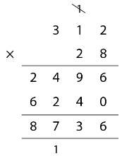  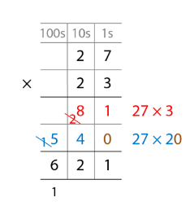  1

Multiplication – Key mental strategies for Key Stage 2
Strategy | Concrete (Can we make it?) | Pictorial (Can we draw it?) | Abstract (Can we write the equation?)
Adjacent multiples of __ have a difference of __.  Year 3 onwards | 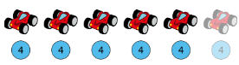 | 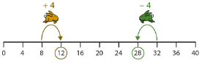 | 4 x 6 = 4 x 5 + 4  4 x 9 = 4 x 10 - 4
Products in the 10 times table are double the products in the 5 times table.  Products in the 5 times table are half of the products in the 10 times table.  (NCETM Year 2 unit 2.5)  Year 3 onwards | 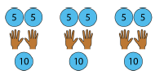 | 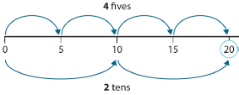 | 5 x 4 = 10 x 2
Products in the 4 times table are double the products in the 2 times table.  Products in the 2 times table are half of the products in the 4 times table.  Year 3 onwards | 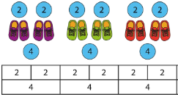 | 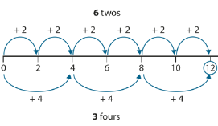 | 2 x 6 = 4 x 3
Products in the 8 times table are double the products in the 4 times table.  Products in the 4 times table are half of the products in the 8 times table.  Year 3 onwards | 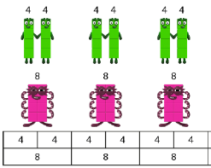 | 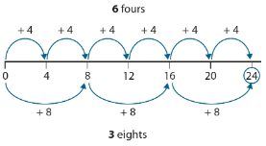 | 4 x 6 = 8 x 3
When both factors are odd, the product is odd.  When one factor is odd and the other factor is even, the product is even.  (NCETM Year 3 unit 2.9)  Year 3 onwards | 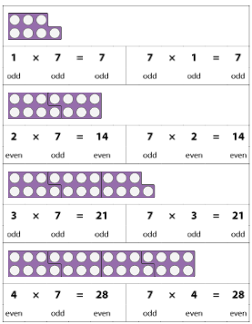 |  | odd x odd = odd  odd x even = even  even x odd = even  even x even = even
Products in the 6 times table are double the products in the 3 times table.  Products in the 3 times table are half of the products in the 6 times table.  Year 4 onwards | 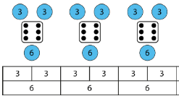 | 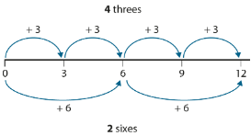 | 3 x 4 = 6 x 2
Products in the 9 times table are triple the products in the 3 times table.  Products in the 10 times table can be used to find products in the 9 times table.  (NCETM Year 3 unit 2.8)  Year 4 onwards | 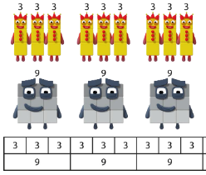  9 x 4 1 x 4  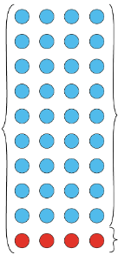  10 x 4 | 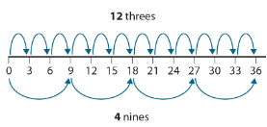 | 3 x 12 = 9 x 4  9 x 4 = 10 x 4 – 1 x 4
Products in the 10 times table can be used to find products in the 11 times table and 12 times table.  Year 4 onwards | 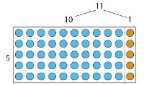 | 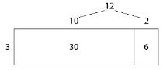 | 12 x 3 = 10 x 3 + 2 x 3  = 30 + 6  = 36

Multiplication Facts
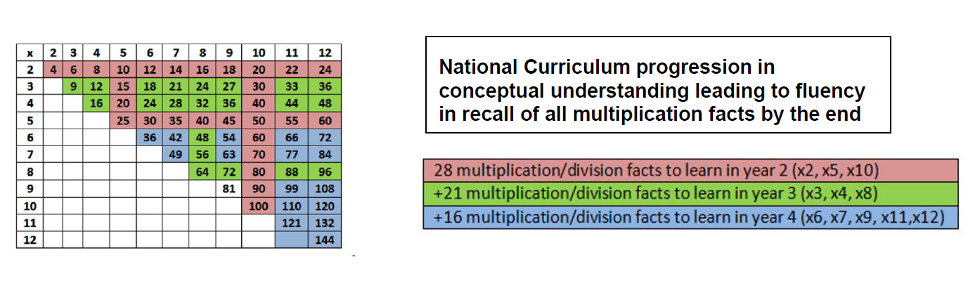
Division
Year 3: Write and calculate mathematical statements for division using the multiplication tables and mental methods
Year 4: Use place and known and derived facts to divide mentally
Year 4: Find the effect of dividing a 1 or 2-digit number by 10 or 100
Year 5: Divide numbers up to 4-digits by a 1-digit number using the formal written method of short division and interpret remainders
Year 5: Divide whole numbers including those involving decimals by 10, 100 and 1000
Year 6: Divide numbers up to 4-digits by a 2-digit whole number using the formal written method of long division and interpret remainders
Year 6: Divide numbers up to 4-digits by a 1-digit whole number using the formal written method of short division and interpret remainders

Stem sentences | Concrete (Can we make it?) | Pictorial (Can we draw it?) | Abstract (Can we write the equation?)
__ is divided into groups of __. There are __ groups and a remainder of __.  (NCETM Year 4 unit 2.12)  Year 4 | 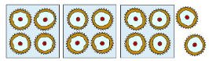 | 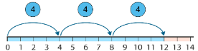 | 14 = 4 x 3 + 2  14 ÷ 4 = 3 r 2
__ is a multiple of __ so when it is divided into groups of __, there is no remainder.  The remainder is always less than the divisor.  (NCETM Year 4 unit 2.12)  Year 4 | 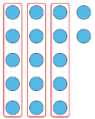  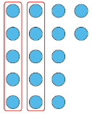  incorrect correct | 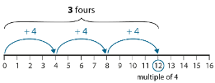  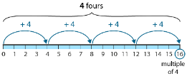 | 17 ÷ 5 = 2 r 7 is incorrect because 7 is greater than 5.  17 ÷ 5 = 3 r 2
To divide a multiple of ten by 10, move each digit one place to the right in place value columns and remove the zero from the ones place.  Year 4 | 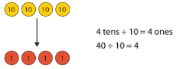  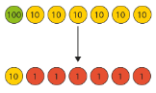 | 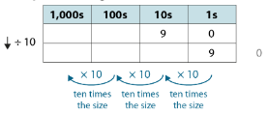 | 90 ÷ 10 = 9  150 ÷ 10 = 15
To divide a multiple of 100 by 100, move each digit two places to the right in place value columns and remove the two zeros (from the tens and ones places).  Year 4 | 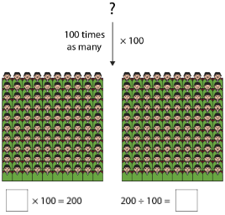  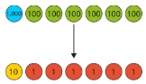 | 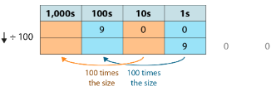 | 900 ÷ 100 = 9  1500 ÷ 100 = 15
If the dividend is made ten times the size, the quotient will be ten times the size.  Year 4 | 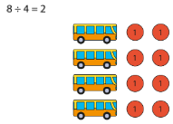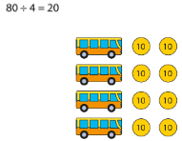 | 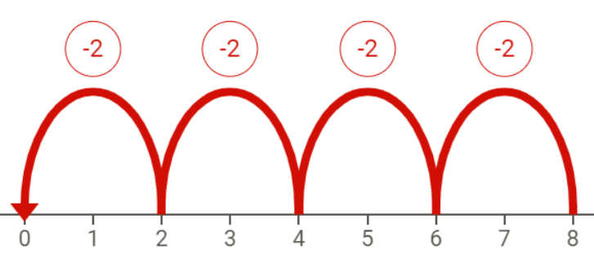  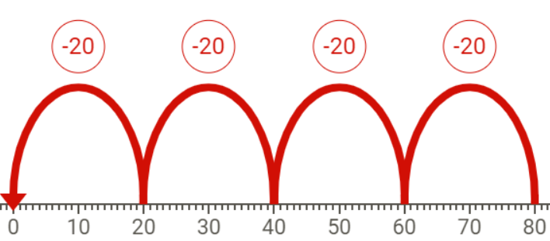 | 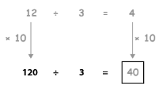
If dividing the tens gives a remainder of one or more tens, we must exchange the remaining tens for ones.  Year 4 | 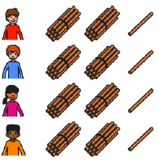  84 ÷ 4 = 21 | 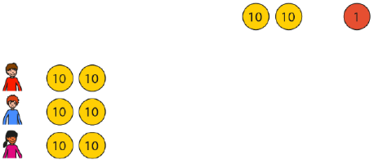  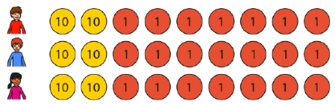 | 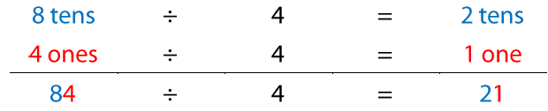  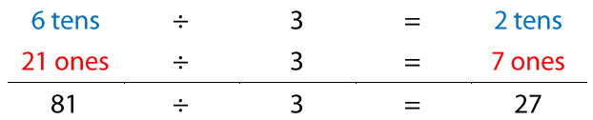
If dividing the tens gives a remainder of one or more tens, we must exchange the remaining tens for ones.  Year 4 |  | 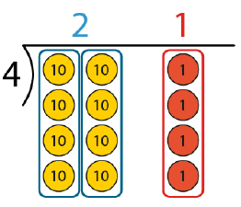  72 ÷ 3 = 24  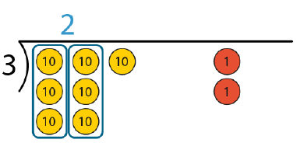  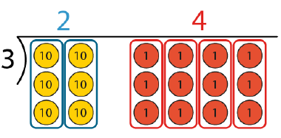  73 ÷ 3 = 24 r 1  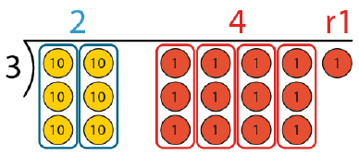 | 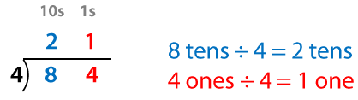  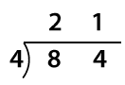  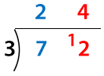  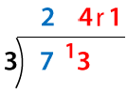
If dividing the hundreds gives a remainder of one or more hundreds, we must exchange the remaining hundreds for tens.  Year 4 | 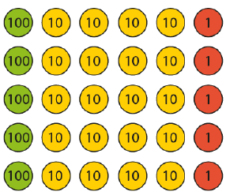    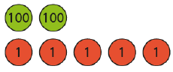 | 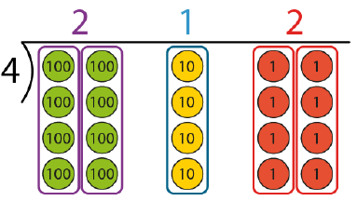  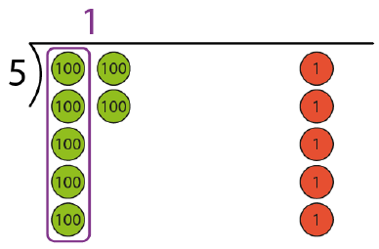  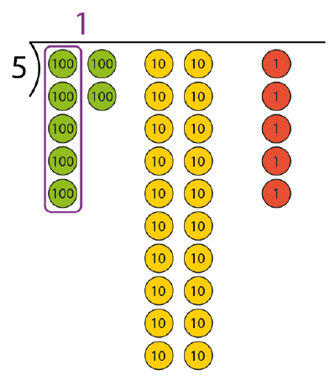  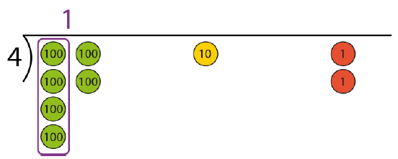  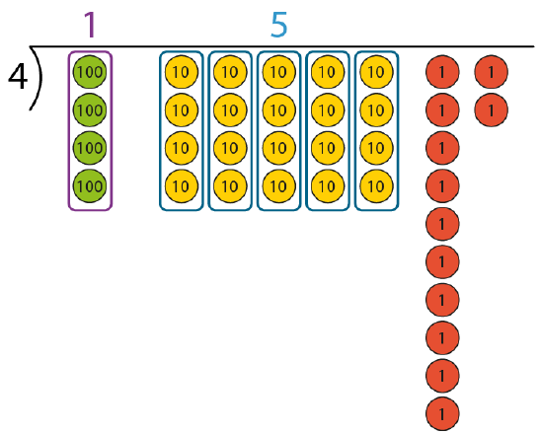  612 ÷ 4 = 153 | 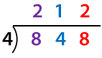  1 4 1  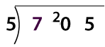  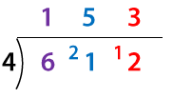
If there is a multiplicative change to the dividend factor and a corresponding change to the divisor, the quotient remains the same.  If I multiply the dividend by __, I must multiply the divisor by __ for the quotient to remain the same.  Year 5 and 6 |   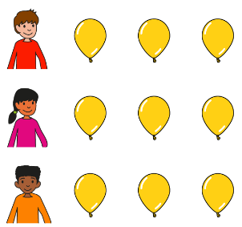  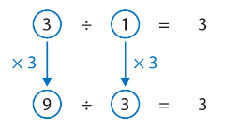 | 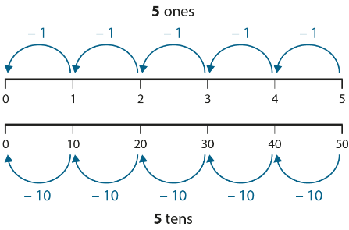 | 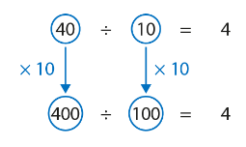
If the dividend is made one tenth of the size, the quotient will be one tenth of the size.  If the dividend is made one hundredth of the size, the quotient will be one hundredth of the size.  I move the digits of the dividend __ places to the left until I get a whole number; then I divide; then I move the digits of the quotient __ places to the right.  Year 5 onwards | 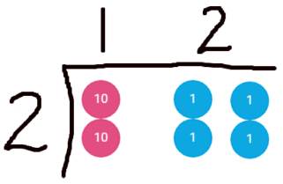  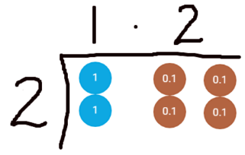 | 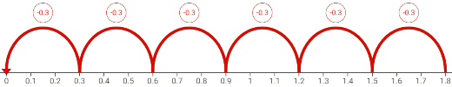  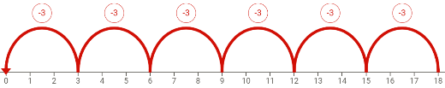 | 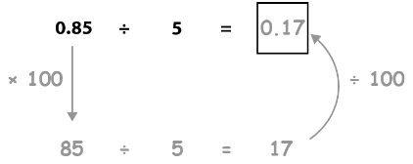  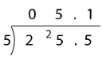  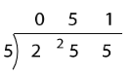
Any two-, three- or four-digit dividend can be divided by a two-digit divisor using skip-counting in multiples of the divisor, or by short division or long division.  Year 6 | 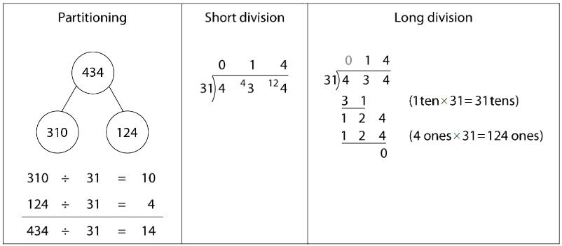
Where there is a remainder, the result can be expressed as a whole-number quotient with a whole-number remainder, a whole-number quotient with a proper-fraction remainder, or as a decimal-fraction quotient.  Year 6 | 

