NAME:
CLASS:
System log in:

Home Learning Website | Username | Password
https://classroom.google.com/ | __________________________@  newmiltonjuniorschool.co.uk  y | 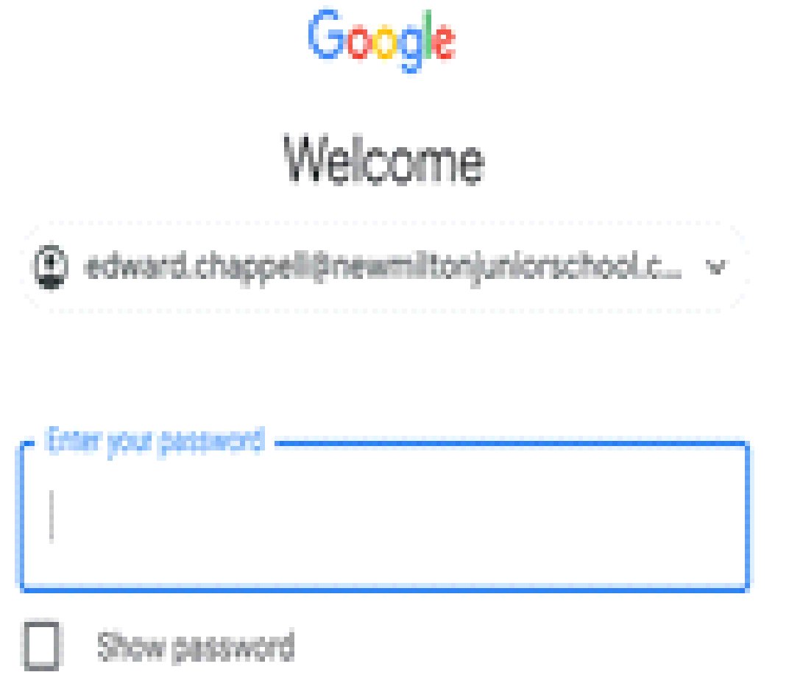
  www.mymaths.co.uk/ | 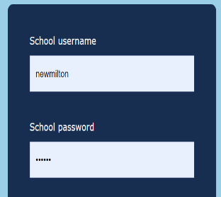  newmilton  circle
  https://ttrockstars.com/ | 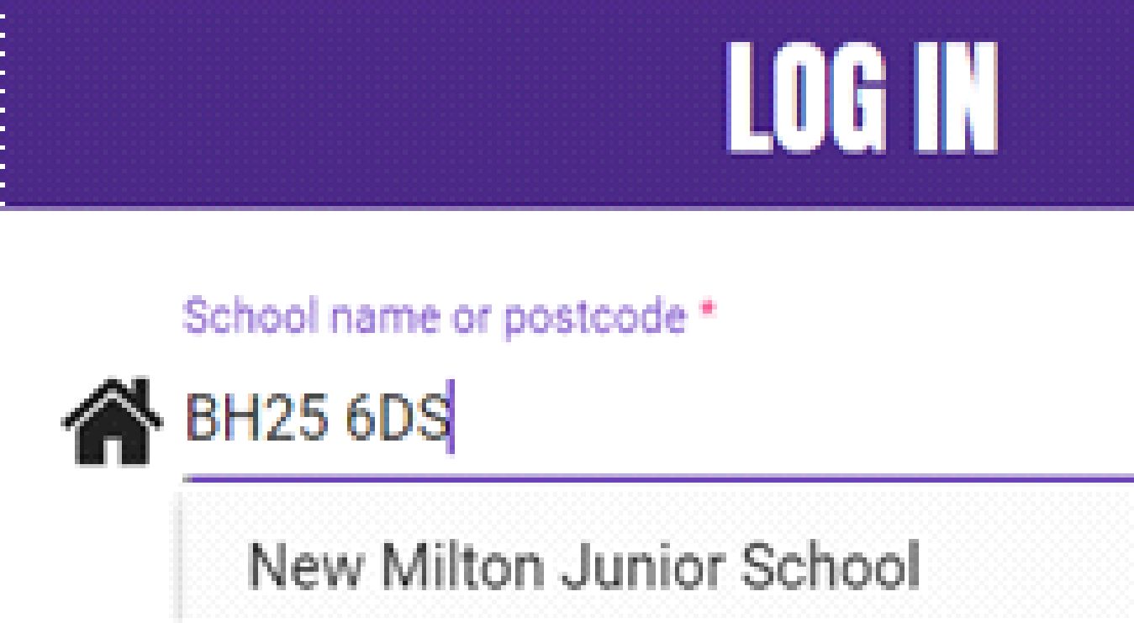
https://spellingframe.co.uk/ | 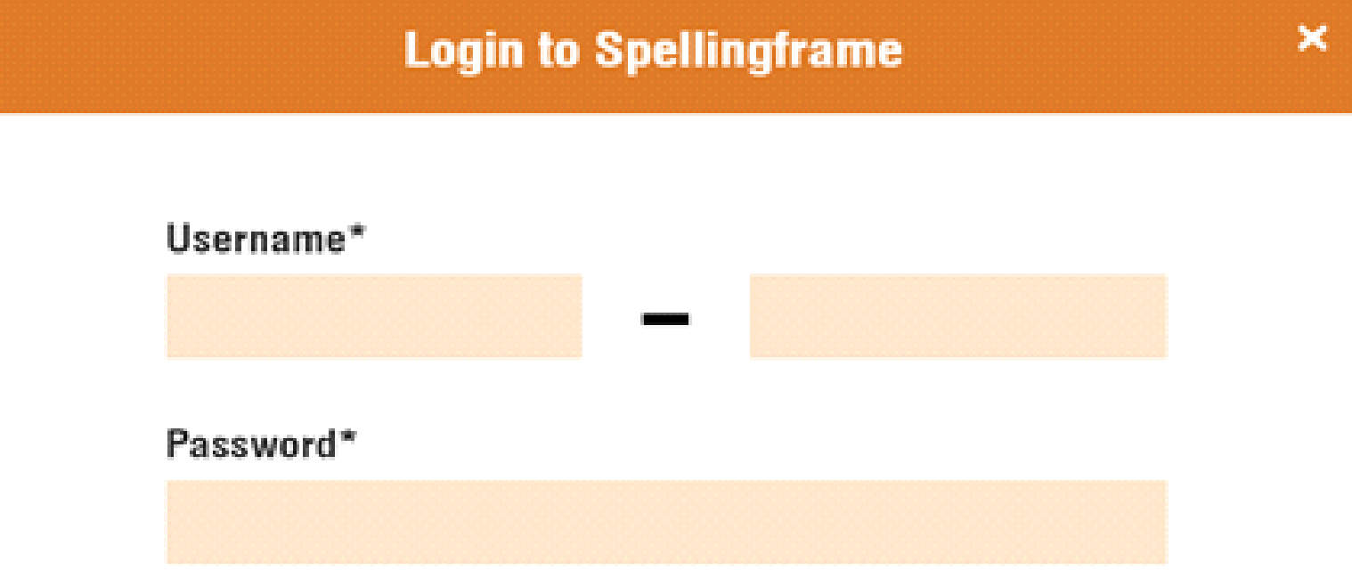
Spelling Shed Dashboard  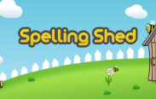 | 

